(Approx. 1205 words)

Tools for Computer Users with Impaired Vision
By Dick Maybach, Member, Brookdale Computer Users’ Group, NJ
March 2018 issue, BUG Bytes
www.bcug.com
n2nd (at) att.net

All of us must deal with our physical limitations, especially as we age; in particular, ten per-cent of all Americans report they suffer from decreased visual acuity. Years ago, our only remedies were using magnifying glasses or having a friend read to us, but today all operating systems either already have or can use readily-available tools to help. There is a chicken-and-egg problem here; those that need these tools may find them difficult to install on a computer without them. If you have visually-impaired friends or relatives, please consider helping them to get started by setting up their computers. (Much of this article is taken from the Website of the American Foundation for the Blind, http://www.afb.org/info/living-with-vision-loss/using-technology/using-a-computer/123.)

Like all users, those with impaired vision must choose between a laptop and a desktop PC, but the factors influencing the decision are somewhat different. Most important is the desktop's larger screen, which can be positioned directly in your line of vision and close to your eyes. Laptop screens are smaller, fixed to the keyboard, and often not at optimal viewing angles. True, most laptops can use external screens and keyboards, but now you have a desktop. And laptops with larger screens are large and heavy, making them not much more portable than a desktop. Also, many users prefer a mouse to a touchpad. Finally, if your vision is significantly impaired, you may rely more on sound than most computer users, and a desktop’s better sound quality may help. It's especially important for people with vision problems to have a comfortable chair and desk, because they will probably spend much time at their computers. If they can use a laptop, they will need a power outlet near where they use it, and wireless Internet access to reduce the cable clutter. Those with desktops should probably place it in a common area, rather than an isolated computer den.

The choice of operating system isn't significant, as Windows, OS X, and Linux all have good provisions for users with impaired vision. At present OS X doesn't use a touch screen, but this isn’t significant as they are awkward for prolonged use when the screen is vertical.

﻿Often vision impairment develops gradually, and for many, enlarging the content of the screen is all that's needed. Regardless of how you take in the content of the screen, this is only a portion of your communications with the machine; you also must enter information, and the key element for this is the keyboard. Those with poor vision often have difficulty accurately placing the cursor with the mouse, making good touch-typing skills more important than for other users. There are many programs that help you learn this, for example PowerTyping, https://www.powertyping.com/, is an on-line tool requiring only a browser and an Internet connection, making it usable with any operating system.

The two main computer accessibility tools are screen magnifiers and screen readers. Those with little or no usable vision will probably use screen reading software, which reads aloud all the text and text-based elements displayed on a computer screen. Those with some usable sight might find screen magnification software, which enlarges the information displayed on a computer screen, helpful either on its own or used with a screen reader. Built-in versions of screen readers and screen magnifiers are included with both OS X and Windows. Linux users will have to do some digging, but equally usable tools are available for them.

I’ll use the Windows 7 Ease of Access Center to illustrate what sort of tools are available to help those with limitations; see Screen 1. Although their details are different in other operating systems, their natures are quite similar. They are also continually improving, with the result that upgrading to a later version of your operating system will probably make better aids available.

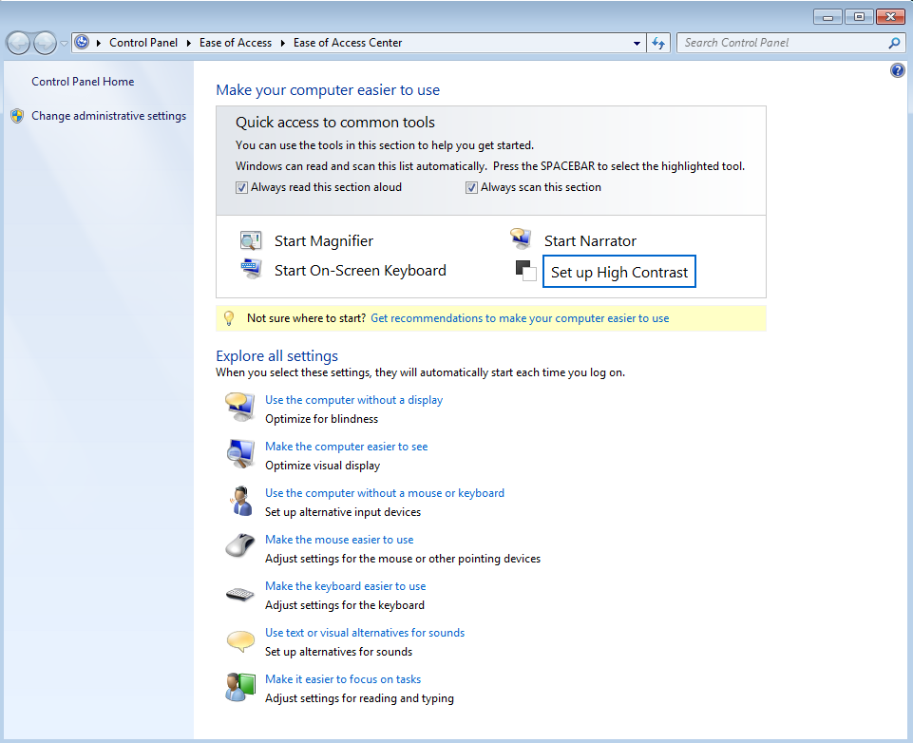
Screen 1. Windows 7 Ease of Access Center.

The most commonly-used tools appear in the quick-access box at the top, and all are available in the list below it. Note the text with a yellow background just below the tools box, which offers to help you find the right tools.

The magnifier displays a window in which a portion of the screen is magnified; see Screen 2.

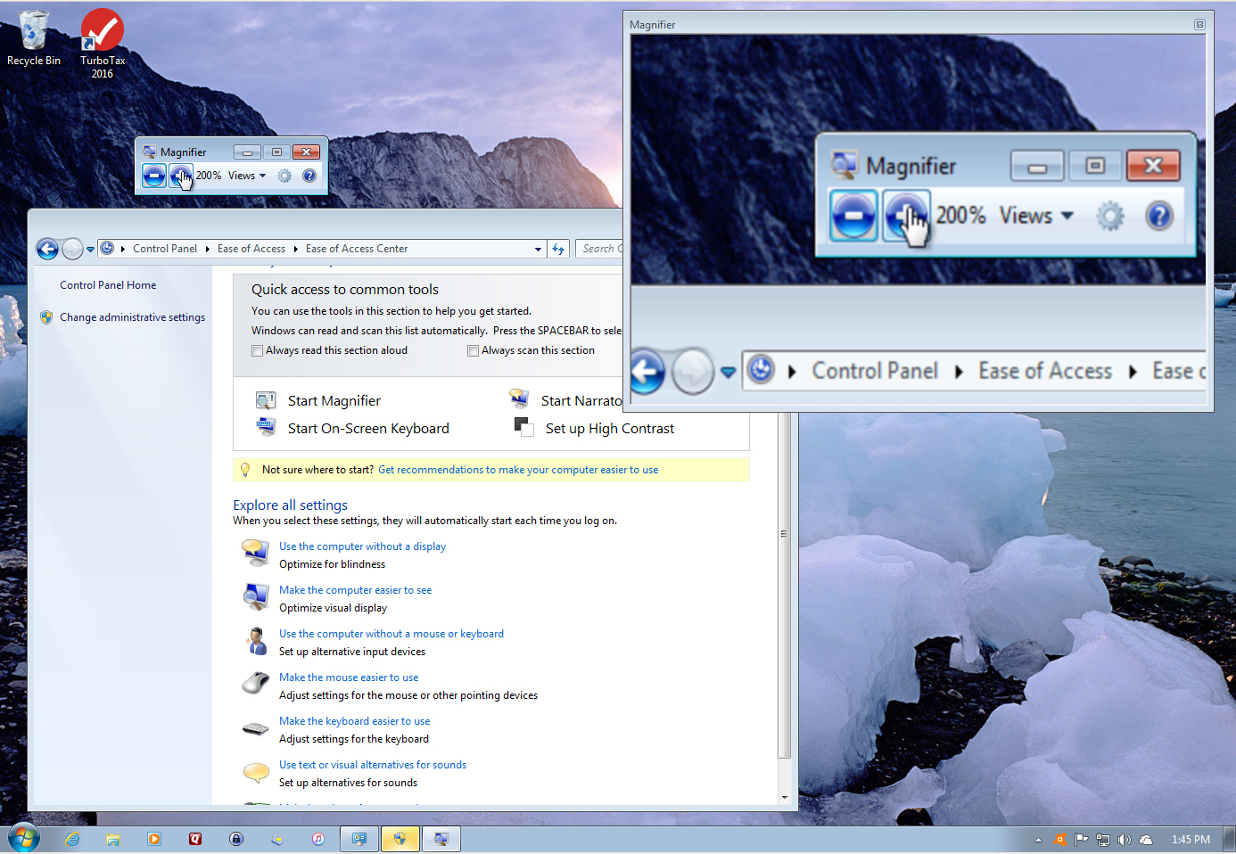
Screen 2. Magnifier.

The size and position of the magnified window as well as the amount of magnification are adjustable but using it effectively will take a little practice. For example, if the cursor is within the magnified window it changes to crossed arrows and can only move the window. To access an item on the main screen, you must move the cursor off the magnified window. This means you will want to keep the magnified window fairly small and you will be moving it frequently. Note in Screen 2 that the cursor on the button that increases magnification and that it’s shown both on the main screen and on the magnified one. As you move the cursor, the magnified view changes so that the magnified cursor is always in the center of this window.

The narrator converts screen text into speech. Windows also has a speech recognition tool that converts your spoken words into text. To find it go to the Control Panel and select the Ease of Access item. The on-screen keyboard might be helpful for those who find typing difficult; see Screen 3. As with the magnifier, you can adjust its size and position.

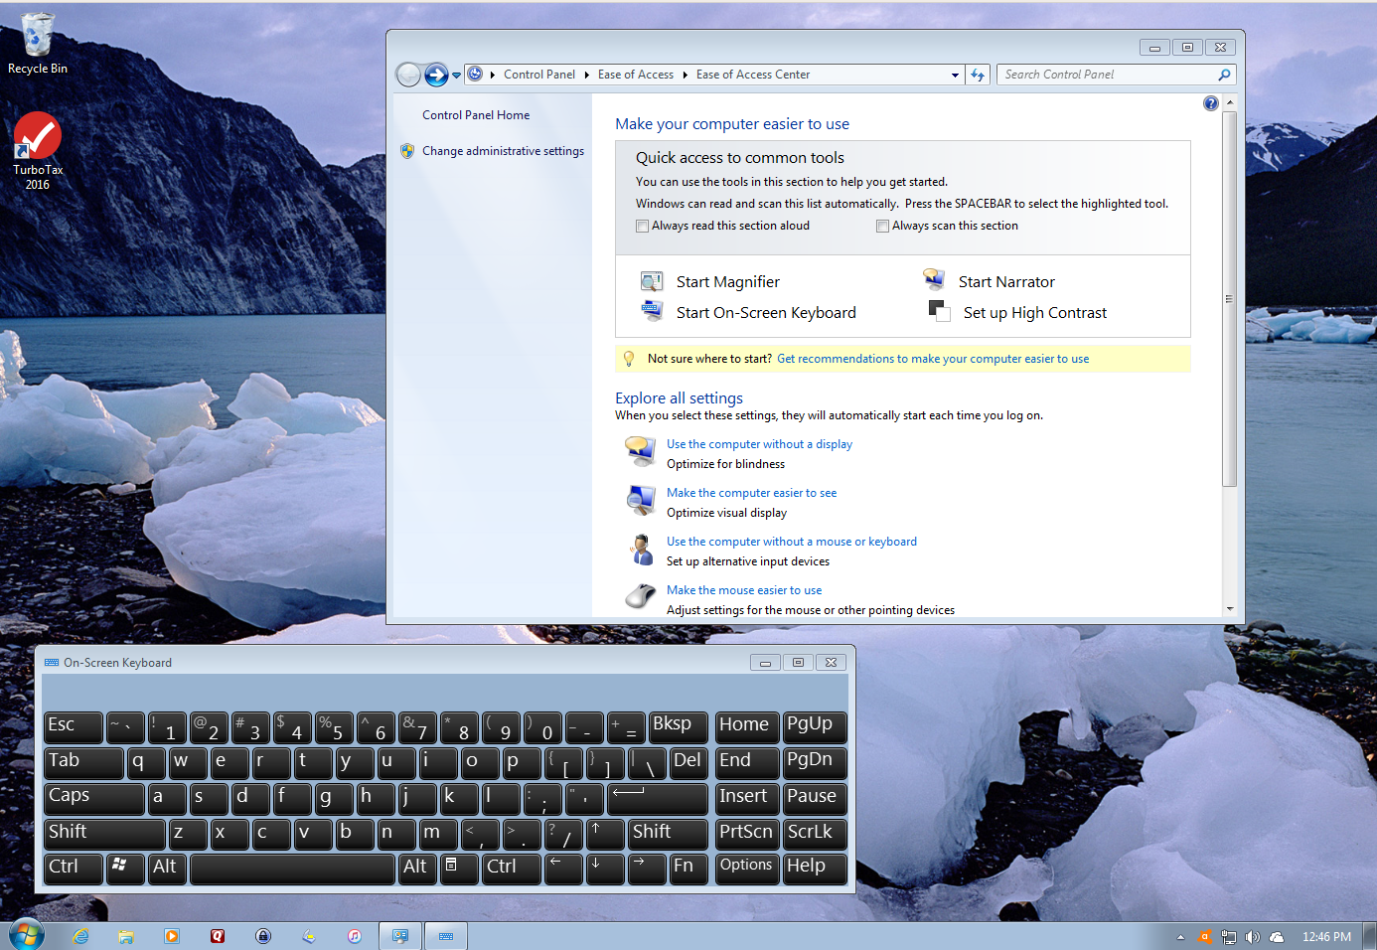
Screen 3. On-screen keyboard.

For some, a high-contrast screen may be easier to read; see Screen 4. Selecting this item in the shortcut box enables the feature and opens the “Make the screen easier to see” item. Now simultaneously pressing the left-shift, alt, and print-screen keys toggles the feature. Microsoft made this feature easy to enable and disable, because its usefulness depends on the screen content.

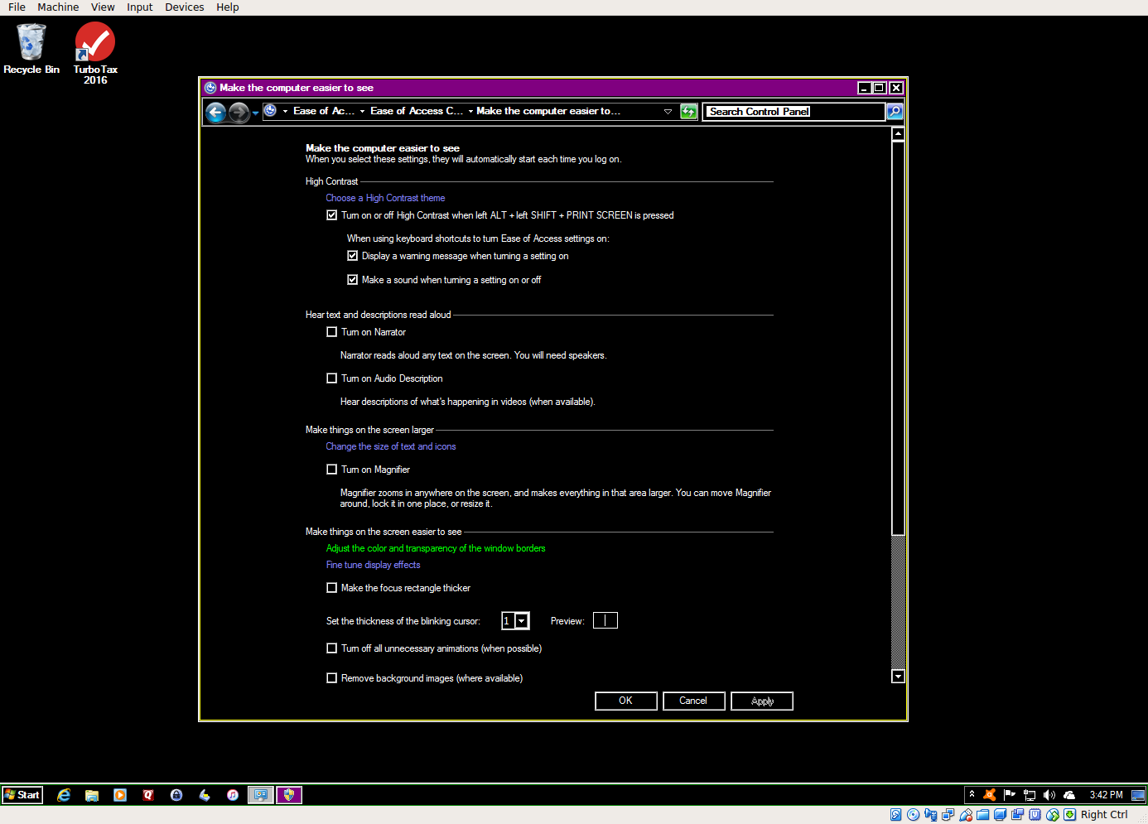
Screen 4. High-contrast Display.

The items in the Explore-All-Settings list provide guidance in overcoming many limitations, not just those concerning vision.

The above discussed the Windows Ease of Access Center, but similar features are available for Mac and Linux users, although the details differ somewhat. My goal here is to make you aware of what is available to help users with physical limitations rather than provide step-by-step instructions.

Android, iOS, and Kindle devices offer accessibility features for vision, including gestures to enlarge the image on the screen, a screen reader, and a high-contrast mode. However, not all apps accommodate these features, and not all device vendors include them. When purchasing an Apple portable device for a user who is visually impaired, get one with both a camera and SIRI built in. The camera can be used with some applications as a magnifier and an Optical Character Reader (OCR), and the SIRI digital assistant is responsive to voice commands.

Microsoft has guides on overcoming different limitations; see http://www.microsoft.com/en-us/accessibility. Apple has done the same; see http://www.apple.com/accessibility/. As usual, Linux users will have to do a little digging. There are Linus distributions tailored to help folks overcome limitations, http://opensource.com/life/15/8/accessibility-linux-blind-disabled. There are also individual tools available, http://linuxdocs.org/HOWTOs/Access-HOWTO-1.html. A list of many sites that discuss this topic is available at http://mielke.cc/blind.html.

